**District Calendars**

How to add District Calendars to your Office 365 / Outlook Account.

1. Log into your email
2. Select the calendar view
3. 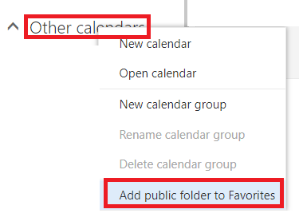Right Click on **Other Calendars** title
4. Select Add Public Folder to Favorites
5. 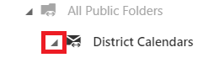Click on the arrow to expand District Calendars
6. Click on a calendar you would like to add, Select Add to Favorites

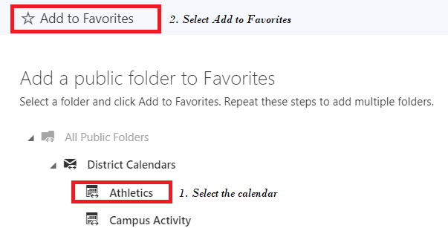

1. Repeat step 6 until you have added all of the calendars that would meet your needs.